**Jira Guide**

First go to this link, where you can find 2021.ai’s Jira dashboard   
<https://2021ai.atlassian.net/>

**Signing up for an account**

If you do not have a user account, your JIRA Administrator will send you an invitation via link

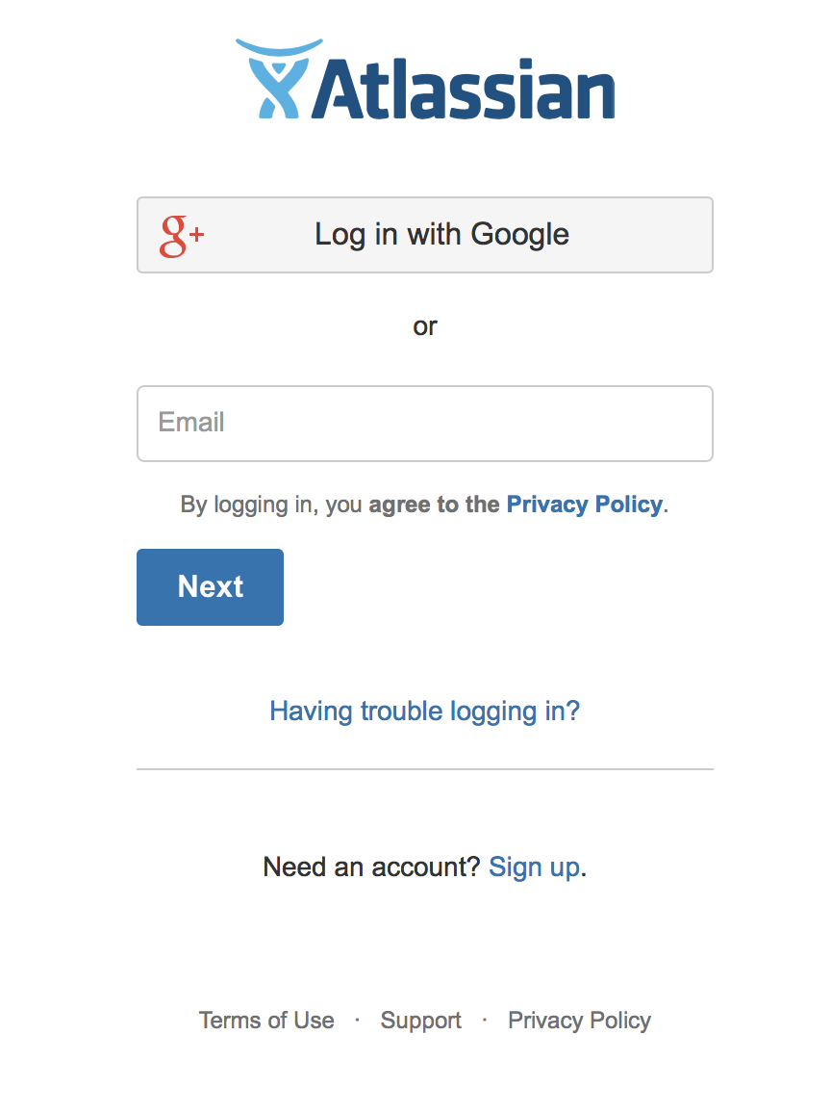

Enter your **Username** and **Password** and click the **Log In** button or log in with your 2021.ai Gmail account.

**Inviting users to join 2021.ai dashboard** - *please note only users with administrate permissions will be able to invite new users.*

1. Choose **Invite Users** on the dashboard.  
   Or take the longer route: Choose the**cog icon** https://confluence.atlassian.com/conf57/files/701434319/701434320/1/1421380756972/Cog.png, then choose **General Configuration** under Confluence Administration Then choose **Users** > **Invite Users**.
2. Copy the **Invitation Link** and paste it into an email message, or onto a page on your intranet, for example.  
   1. Enter one or more email addresses in the field labelled **Email To**. Separate the addresses with commas. For example:   
      yina@example.com, chris@example.com
   2. Choose **Send**.

**Adding users manually**

**To add a new user:**

1. Choose **Invite Users** on the dashboard, then choose **Add Users**.  
   Or take the longer route: Choose the**cog icon** https://confluence.atlassian.com/conf57/files/701434319/701434320/1/1421380756972/Cog.png, then choose **General Configuration** under Confluence Administration Then choose **Users** > **Add Users**.
2. Enter the user's details: username, name, password, and email address.
3. Choose whether Confluence should send an **email** message informing the person of their new username. The email message will contain a link that the person can use to reset their password.
4. Choose **Create**.

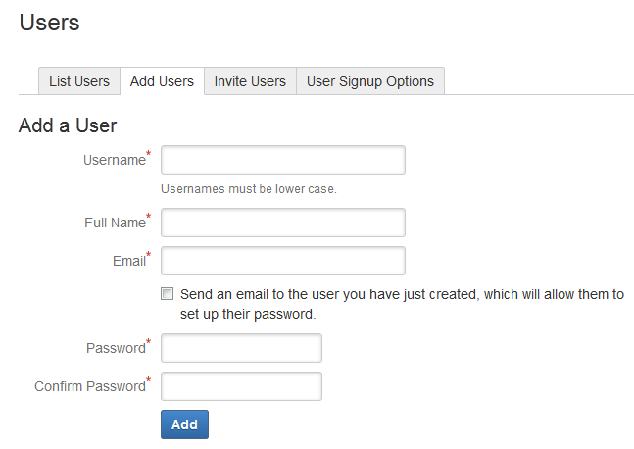

**Logging in your work hours**

Create a new issue by clicking the create button at the top of the page.

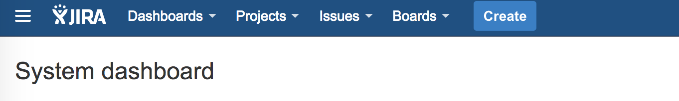

Choose the project associated with your work hours and fill out the form like below

1. **Project:** “…. Project Hours (SPH)”
2. **Issue Type**: Task
3. **Summary**: “Name Project Hours Date 21st to Date 20th Year”

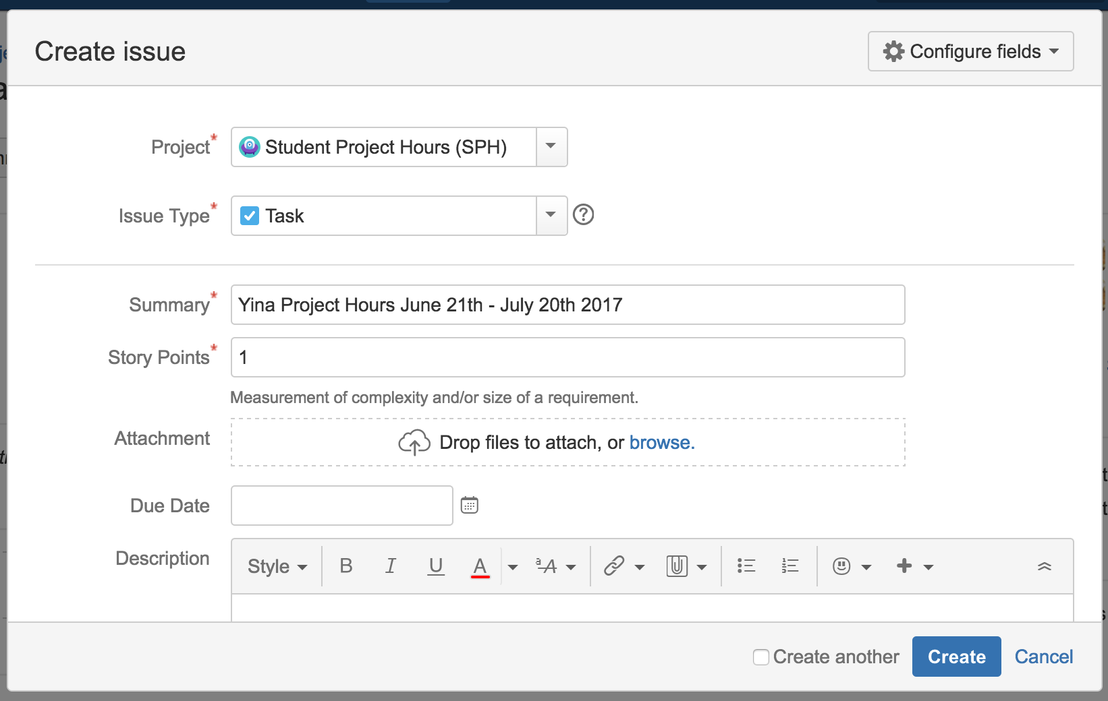

Assign the issue to yourself, click create and then you will be directed to that issue

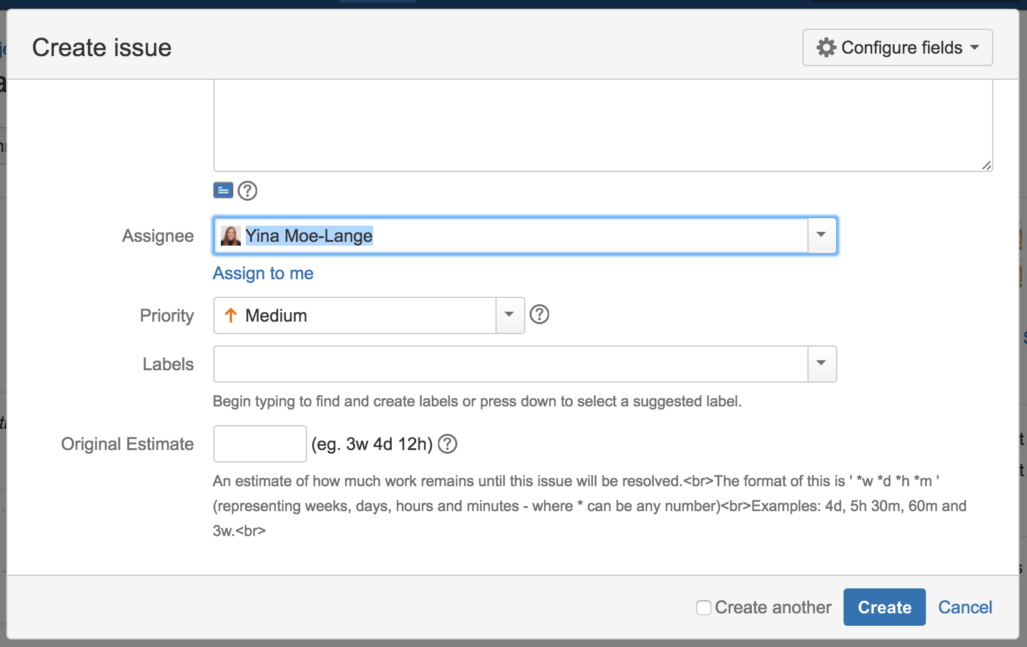

This is the page you will see once you have created your issue

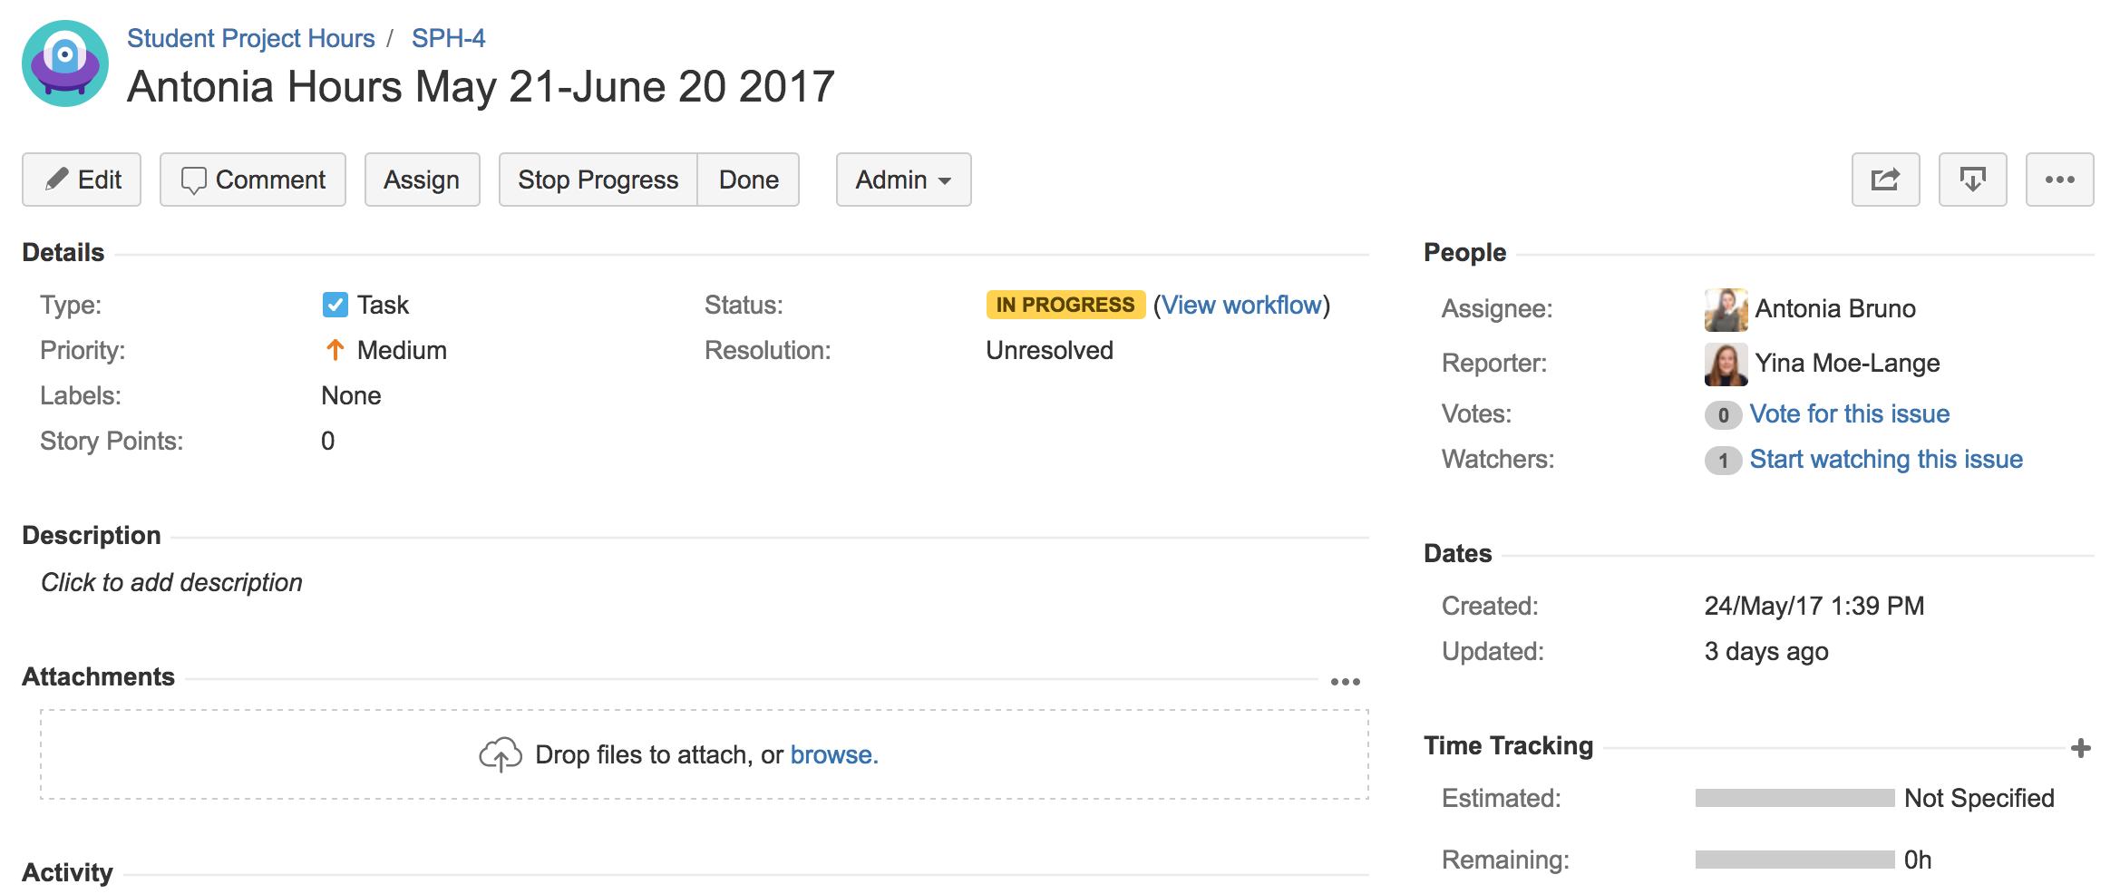

To log in your work hours, go to the more options icon and click Log work

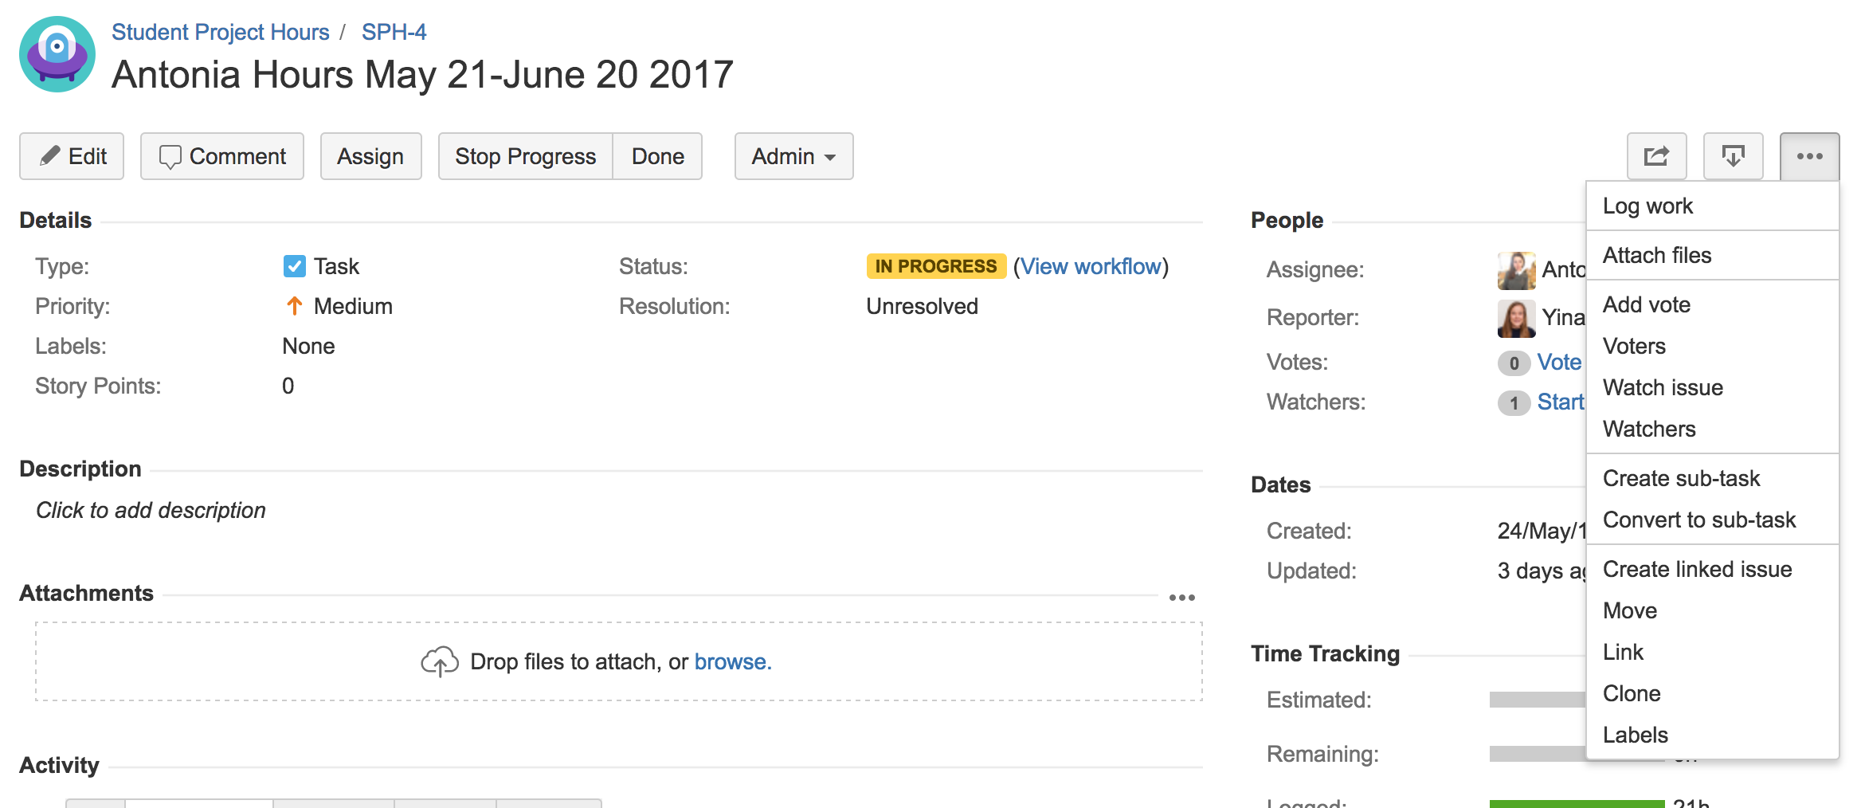

You will then be redirected to this screen where you can log your work hours. Fill out the form like below

1. **Time Spent**: hours + h
2. **Date Started**: From the time, you started work
3. **Work Description**: Time – Time In the office

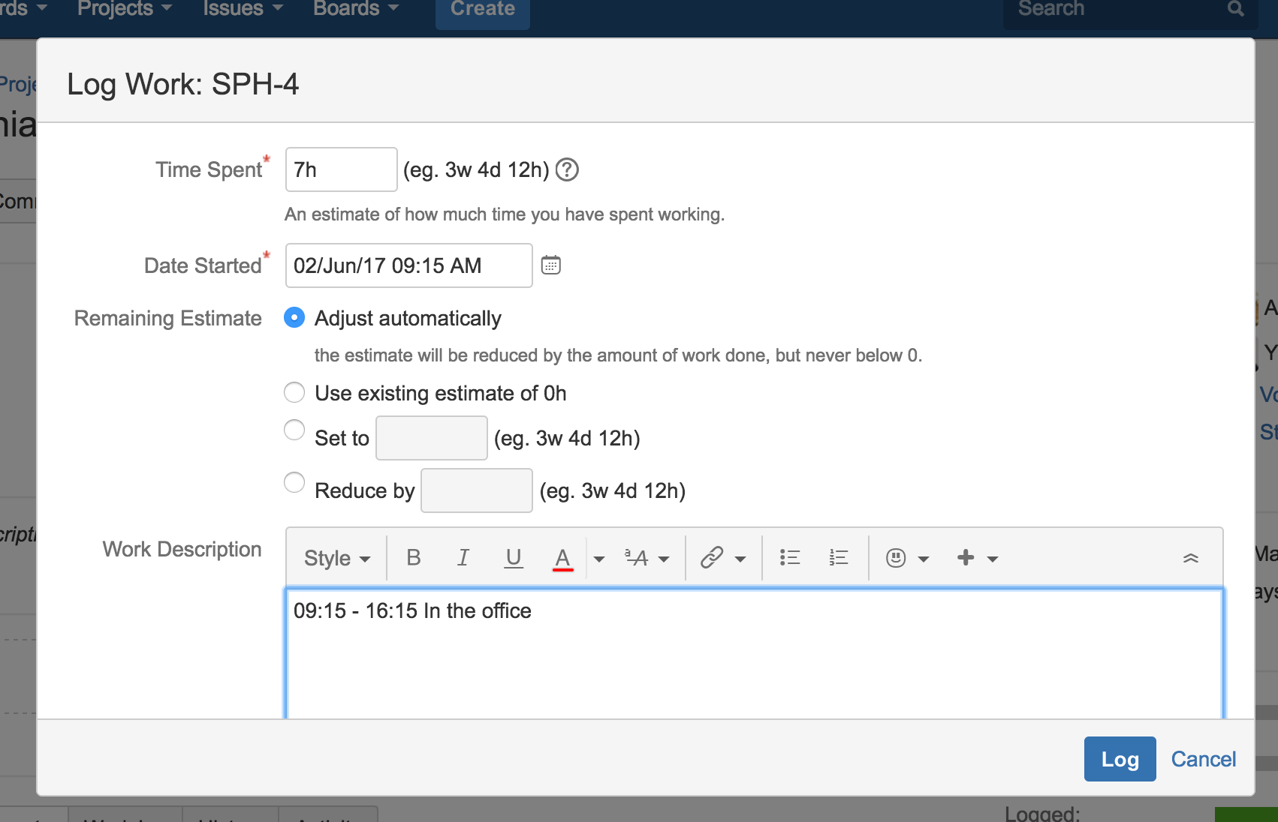

After you will find the hours you have worked in the activity section inside the tab Work log.

